44.1: a) 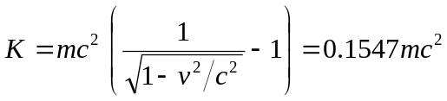
b) The total energy of each electron or positron is 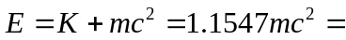
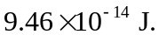 The total energy of the electron and positron is converted into the total energy of the two photons. The initial momentum of the system in the lab frame is zero (since the equal-mass particles have equal speeds in opposite directions), so the final momentum must also be zero. The photons must have equal wavelengths and must be traveling in opposite directions. Equal means equal energy, so each photon has energy 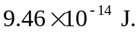
c)
The wavelength calculated in Example 44.1 is 2.43 pm. When the particles also have kinetic energy, the energy of each photon is greater, so its wavelength is less.

